Reading Guide Chapter 2: Population & Health
Key Issue 1 Where are the World’s People Distributed?
Pages 46-51
Introducing Population and Health
- What are three reasons why studying population geography is so important?

2. What is overpopulation?
3. What is a census? What are the two reasons why the census can be controversial?

4. Compare Figures 2-2 and 2-3 on page 47. Which depicts the shape of countries more accurately? Why?

Population Concentrations
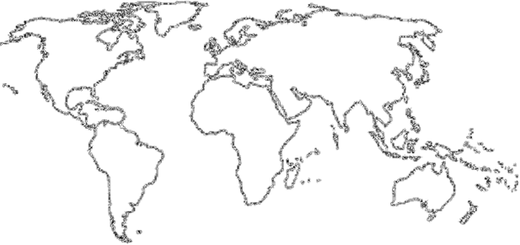
5. The world’s population is highly clustered, or concentrated in certain regions. FOUR major population concentrations are identified in the text. Shade and label the areas of these concentrations on the map in red. TWO smaller concentrations, or emerging clusters, are also identified. Shade and label these areas on the map in blue.

6. In the boxes below, make note of significant facts, features, countries involved, and characteristics of the four most important population concentrations and two secondary ones.

EAST ASIA |  | SOUTH ASIA
SOUTHEAST ASIA | EUROPE |  | EASTERN NORTH AMERICA  WEST AFRICA
7. Define ecumene:

8. What would non-ecumene mean?

9. In the table below, list the four “lands” which are sparsely populated on earth. For each region, explain the reason which makes it inhospitable for human habitation.
Sparsely Populated Land | Reason(s) for Inhospitality
Dry Lands
Wet Lands
Cold Lands
High Lands

10. Use the maps on page 49 to prepare a sketch map that shows non-ecumene and very sparsely inhabited lands.
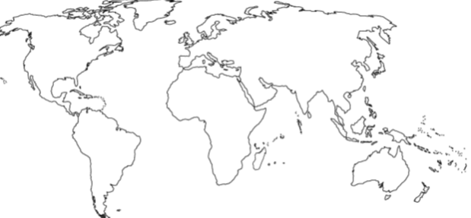

Population Density

11. Define arithmetic density:

12. Define physiological density:

13. Define agricultural density:

14. Compare and contrast the physiological density and the agricultural density of the Netherlands and Egypt.

